# Lab: 10

Task 1:

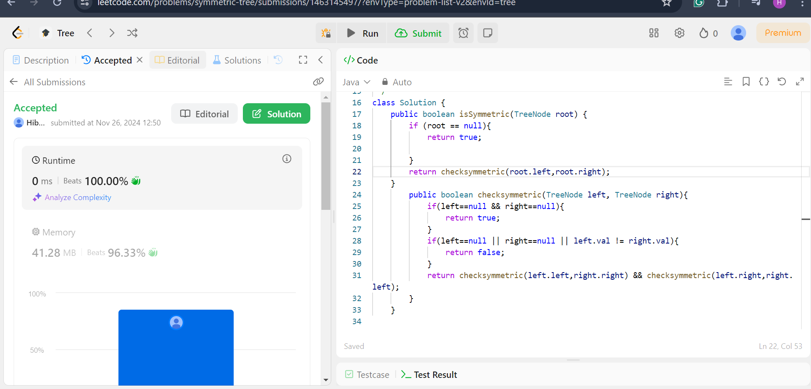

Task 2:

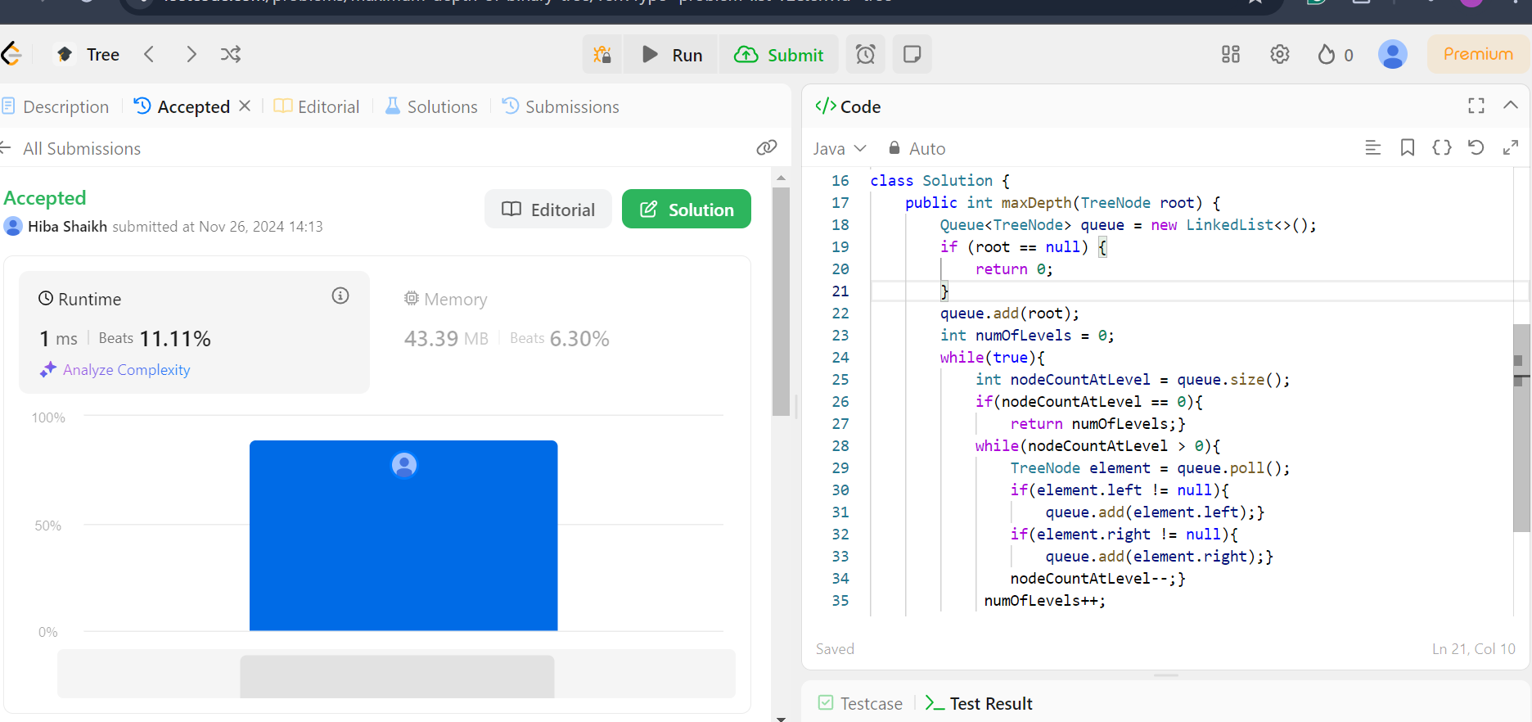

Task 3:

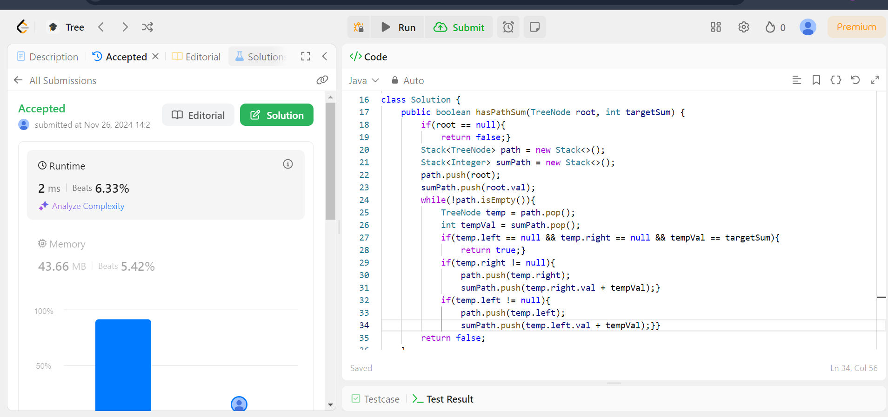

Task 4:

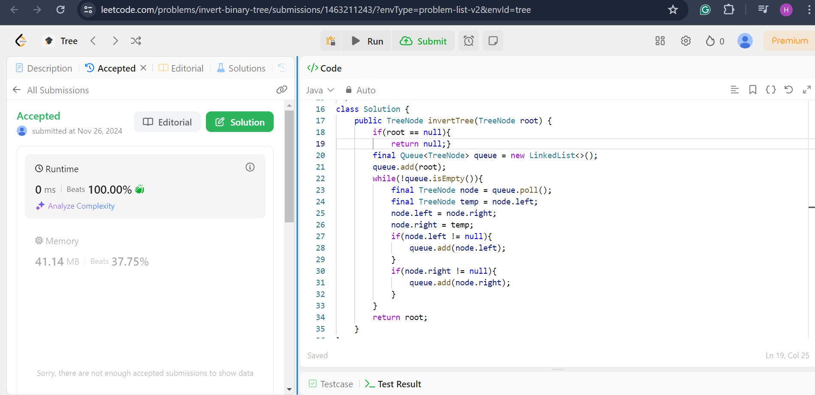

Task 5:

